[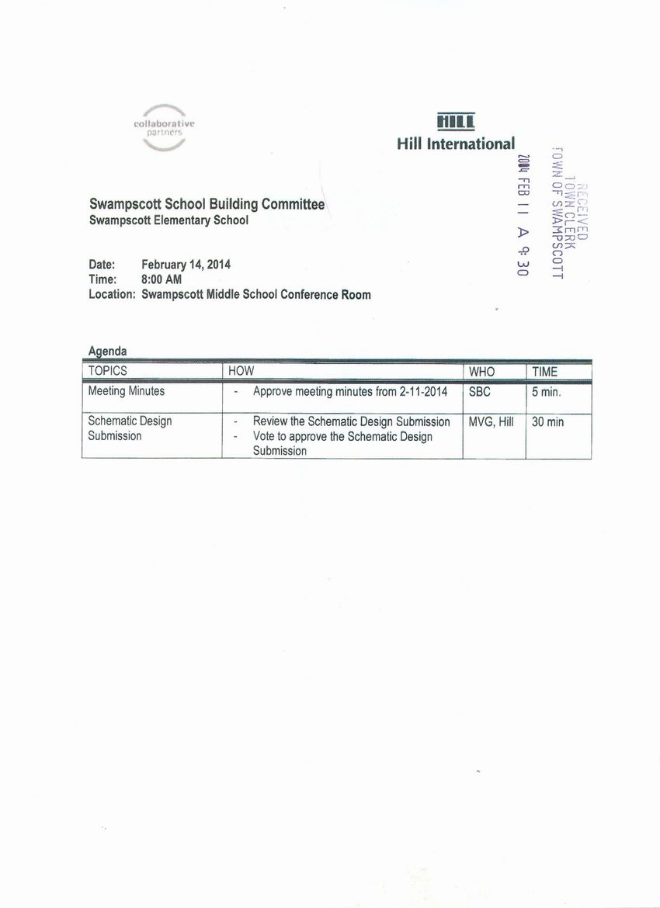](http://www.town.swampscott.ma.us/Public_Documents/SwampscottMA_Calendar/S045D8219-045D8247.0/SBC%20Feb%2014th%20notice3%20001.jpg)